T.C.
İSTANBUL KÜLTÜR UNIVERSITY
FACULTY OF ENGINEERING
DEPARTMENT OF INDUSTRIAL ENGINEERING

IE7803 INDUSTRIAL TRAINING II
INTERNSHIP REPORT
A Project Report Presented to
Department of Industrial Engineering
İstanbul Kültür University
In Partial Fulfillment of the Requirements
For Internship Course

Internship Period:
DD/MM/YYYY - DD/MM/YYYY

By
< Student Name >
< Email Address>

Employer Information
< Company Name >
< Name of Manager >
< Contact Info for Manager >

TABLE OF CONTENTS
1. COMPANY INFORMATION 2
1.1. Organizational Structure 2
1.2. Operations of Business Functions 2
2. INTERNSHIP EXPERIENCE 3
2.1. Roles and Responsibilities of the Department 3
2.2. Internship Responsibilities and Duties 3
3. PRODUCTION SYSTEM 4
4. OBSERVATIONS ON COORPORATE SUSTAINABILITY 6
5. COMPANY/INTERNSHIP EVALUATION 7

COMPANY INFORMATION
[This section must be minimum 5 pages].
- Give the organization's location and specify the address.
- State the vission and mission of the company.
- Evaluate the location of the company in terms of:
» Proximity to raw material and market,
» Transportation facilities,
» Water, energy and employee infrastructure,
» Environmental pollution, climate, legislation regulations.
- Give the information about the company's capital structure.
- Indicate the position of the company within the sector.
- Give the information on the company's product range, the current distribution system, and after-sales services (if exists).

Organizational Structure
- Give the information of the company’s organisational structure (organisation scheme), number of employees, educational level of employees, governing structure (centralized, decentralized).
- Build an organization chart of the firm as a figure in English (i.e. Figure 1). 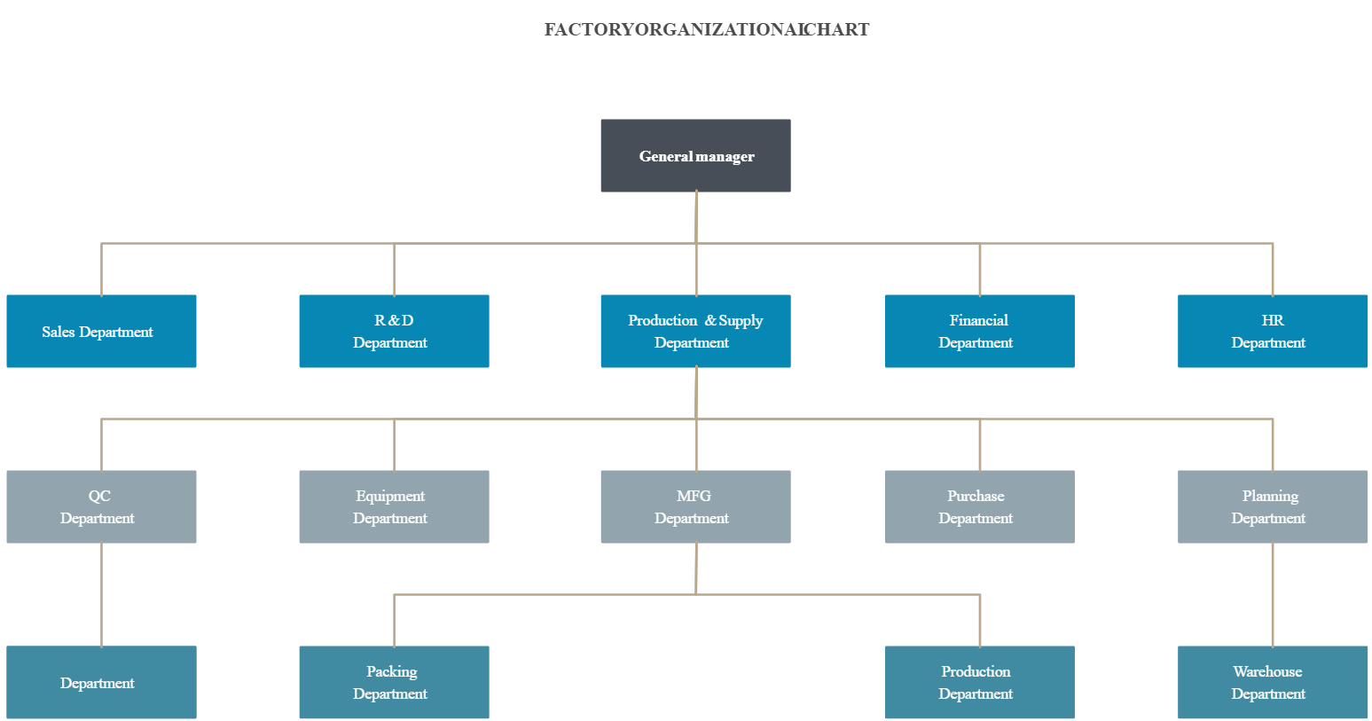
Figure 1. Organizational chart of the firm or … department

Operations of Business Functions
- Give the details of company’s Information Technologies (IT) (softwares, databases, network connections, number of computers, absence of necessary IT applications, planned investments in IT, your evaluations.).
- Indicate Industrial Engineering activities within the organization.

INTERNSHIP EXPERIENCE
[This section must be minimum 7 pages].
Explain your duties, observations, suggestions about your internship as general that includes both company and yourself.

Roles and Responsibilities of the Department
- Give the organizational structure of the department, responsibilities of individuals, which departments has the relations with your department.

Internship Responsibilities and Duties
- Develop a Gantt Chart to show your daily activities as given the below table.
- Explain the tasks in detail.

Table 1. Gantt Chart representation of the internship period.
Tasks | Days
 | 1 | 2 | 3 | 4 | 5 | 6 | 7 | 8 | 9 | 10 | 11 | 12 | 13 | 14 | 15 | 16 | 17 | 18 | 19 | 20

PRODUCTION SYSTEM
- Provide information about the company's annual design capacity and used capacity.
- Calculate the unit production cost, direct labor, direct raw materials and overhead items of a product you have selected (no need to use actual numbers). Describe the system used to find the cost. Perform the "Breakeven Point Analysis" of the product with the cost.
- Review the workshops ergonomically and indicate your suggestions and deficiencies you have observed.
- Give the information of the time and work process undertaken. Otherwise, make an application consisting of 10 measurements.
- Give the information of efficiency studies and identify the level of productivity with a few samples.
- Give the information of tools, gears and benchs used in manufacturing.
- Provide information on material handling, storage systems and inventory management. Indicate any deficiencies you have observed, and discuss your suggestions.
- Provide information on the production system applied in the business (group technology, cellular production, assembly line, etc.).
- Provide information and examples about production planning activities.
- Give information on activities and methods applied for quality control with examples.
  - Incoming control processes (for supplies),
  - ​In-process 'product' controls (during operations),
  - In process 'process' controls (during operations),
  - Final control processes (for outgoing products),
- Provide information about the following Industry 4.0 technologies/applications (showed in the table below) that are available in the company. Indicate the applied ones in the table.
Table 2 Usage status of existing technologies
Application | In Use? (Yes/No)
3D Printing
Sensor Systems
Virtual Reality
Cloud Technologies
Internet of Things
Additive (3D) Manufacturing
Improved Robot Technologies
Automation
Modeling and Simulation
Online Education
Electronic Performance Reports
Big Data
Augmented Reality
Cyber Security
Integrated Product Development
Predictive Maintenance
Preemptive Maintenance
Smart Warehouses
Mobile Systems

- Explain how existing technologies given in the above table are used.

OBSERVATIONS ON COORPORATE SUSTAINABILITY
Please give information on the activities performed in the company for the following sustainability concepts:
- Social responsibilities (Occupational health and safety)
- Environmental responsibilities
- Legal responsibilities
- Ethical responsibilities

COMPANY/INTERNSHIP EVALUATION
Student should evaluate the internship and the company.
(A scale of 1 – 10 with 10 being the most positive should be used.)
Evaluation Criteria | 1 | 2 | 3 | 4 | 5 | 6 | 7 | 8 | 9 | 10
I implemented Industrial Engineering methods in the company.
I had chance to improve my knowledge and skills during my internship.
I had support from the company staff during my internship.
I recommend the company for other students’ internships.
I am satisfied with my internship in this company (overall score of the internship).

Please write your experiences for the following topics:
- The strengths of the company
- The weaknesses of the company
- Your learnings and implemented methods during your internship

